Little Wombatz Ltd Coronavirus (COVID-19) Policy

To all service users of Little Wombatz Preschool and wrap around care

Introduction
This policy applies to all Employees, Parents, Children, Volunteers, Students and anyone else working on behalf of the Pre-School and Wrap-around care. This policy also applies to service users and delivery drivers visiting the setting.

Purpose of policy
- Protect all employees, and service users including parents and children from coming into contact with Coronavirus (COVID-19).
- To maintain all aspects of care to children and the staff and continue to provide the welfare needs of the children in our care.
- To prevent the spread of Coronavirus (COVID-19)

Travel
Employees are not required to travel outside of the UK for their job. The setting has requested for its employees travelling to an infected area to take a PCR test two days before their return to England, as well as completing a passenger locator form. They will also need to book a COVID-19 travel test within 2 days of arriving back into England. If the employee is not fully vaccinated, then they will need to complete another PCR test on the eighth day after they return.

Monitoring
The setting is closely monitoring and gathering information from The Department of Health about the spread of Coronavirus (COVID-19) and the management team are communicating regularly before feeding-back to employees. Little Wombatz staff members have a duty of care to communicate with management if they or someone in their household has tested positive for COVID-19. They are then required to isolate for a 10 day period to reduce the risk of infection within the setting.
If a child begins to show signs of coronavirus, Little Wombatz will request that their parents take the child for a PCR (polymerase chain reaction) test and should either have a negative result or have isolated for a 10 day period before they are able to return to the setting. If a child in Little Wombatz’s care has a positive COVID-19 case in their household they are required to isolate from Little Wombatz for a 10 day period.
Staff members should carry out a Lateral Flow Test twice a week
when working within the setting, this will change to daily testing if staff members have identified by NHS Test and Trace as a close contact or if there is an outbreak in the setting. Please inform Little Wombatz by calling 07753662109 or email Littlewombatzpreschool@gmail.com if you are a close contact, have tested positive, or someone in your household has tested positive.

Hygiene - General
Employees are advised to practice good hygiene and cleanliness.
- Regularly wash hands with anti-bacterial soap and water for at least 20 seconds.
- Wash hands on arrival to work and on departure.
- Regularly use hand sanitiser.
- Cover mouth and nose when coughing or sneezing with either a bent elbow or tissue and always wash hands afterwards.
- Avoid close contact with others, such as handshakes and if possible, try maintain a social distance of 2 meters. Parents are not to enter the setting, unless out of hours or pre-arranged.
- Avoid touching your eyes, nose and mouth.
- Wash all uniform after each session with the children

Transmission of Coronavirus
To help ensure the Coronavirus does not spread internally through the setting, the following actions are being taken;
- Frequently touched areas are appropriately cleaned several times a day. These include; desks, laptops, door handles, switches and telephones. The toilet area, tables and chairs which are being used by the children, as well as heavily used toys and equipment.
- Hand sanitiser is being used frequently within the setting. Staff and children are encouraged to sanitise their hands upon arrival to the setting and again on departure.
- If an outbreak is confirmed Little Wombatz LTD will prioritise enhanced cleaning protocols and hygiene measures. Any anticipated break in service for cleaning will be communicated with all parents and partners if necessary.

Face Coverings
Employees, students, volunteers, and visitors are not required to wear a face covering whilst inside the setting but can do so at their own discretion.
Little Wombatz staff are required to wear a face covering whilst in school grounds when collecting or dropping off the wrap-around children. This is subject to change with guidance from schools and/or the government. Little Wombatz can provide face coverings for staff members, parents or visitors if needed.

If an employee experiences any of the following symptoms they will inform a member of the management team immediately, self-isolate and contact 111 for advice.

Symptoms include:
- A continuous cough
- A high temperature
- Shortness of breath
- Loss of taste and smell
These symptoms are similar to cold or flu.

Business Continuity
It is vital that Little Wombatz continue to care for the children entrusted to us. We will do this whilst providing the necessary health and safety systems for the employees and visitors in our setting.

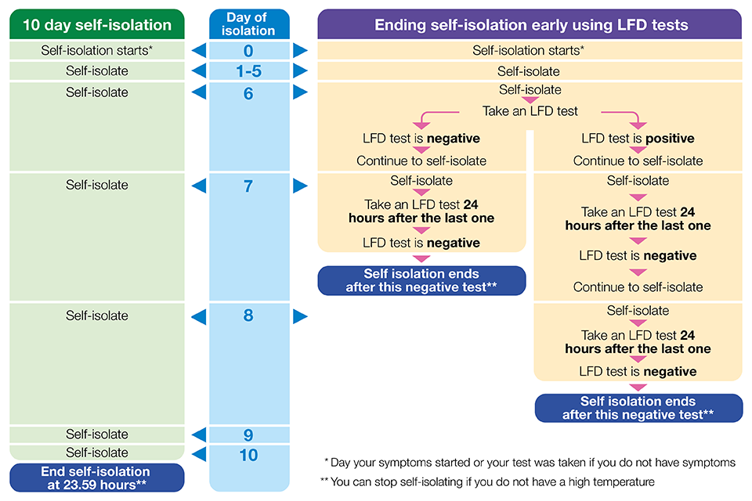

Dated: 6th January 2022

